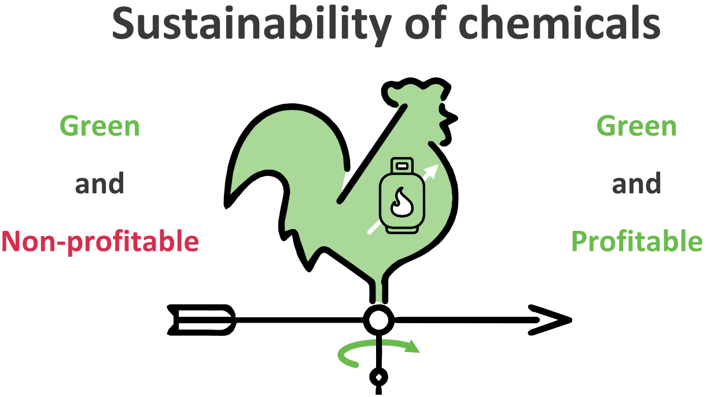
Europe's energy crisis has made green routes for ammonia and methanol synthesis economically competitive. This presents an opportunity for Europe to lead the grand transition towards a sustainable chemical industry.
THE PROBLEM OF THIS DESIGN IS THAT THE MAIN FACTOR, I.E., ECONOMIC COMPETTITIVENESS, IS ONLY INDIRECTLY HERE. YOU ARE TAKING FOR GRANTED THAT ALL PEOPLE KNOW THE EQUATION SUSTAINABILITY = GREEN + MONEY
YOU CAN WRITE SUSTAINABILITY OF PLATFORM CHEMICALS AND SUBSTITUTE UNSUSTAINBLE BY NON-PROFITABLE AND SUSTAINABLE BY PROFITABLE. THEN EVERYTHING IS THERE

